SIMATS ENGINEERING
ASSESSMENT TOOL 1 - Short Answer Test

COURSE NAME: COMPUTER VISION FOR AUTONOMOUS VEHICLES COURSE CODE: ITA0546

COURSE OUTCOME COVERED

CO1: Apply the fundamental concepts, image formation models, and processing techniques for analyzing Computer Vision systems. (BTL 3)

Assessment Tool Weightage: 40%

QUESTIONS

- Given a real-world scene captured under low light, describe how the image sensing and acquisition process influences the final digital image.
Explanation: In a low-light environment, the camera sensor receives less light, resulting in a darker image with more noise and reduced details. During image acquisition, the sensor converts light into electrical signals, which are then digitized. If the captured light is insufficient, the digital image may have poor brightness, low contrast, and noise. Image enhancement techniques such as brightness adjustment and contrast improvement are used to produce a clearer digital image.
Code:
import cv2
import matplotlib.pyplot as plt
import urllib.request

# Download a sample image
url = "https://raw.githubusercontent.com/opencv/opencv/master/samples/data/lena.jpg"
urllib.request.urlretrieve(url, "sample.jpg")

# Read image
image = cv2.imread("sample.jpg")

# Create a low-light version
low_light = cv2.convertScaleAbs(image, alpha=0.4, beta=-20)

# Enhance the low-light image
enhanced = cv2.convertScaleAbs(low_light, alpha=1.8, beta=40)

# Convert to RGB
low_light = cv2.cvtColor(low_light, cv2.COLOR_BGR2RGB)
enhanced = cv2.cvtColor(enhanced, cv2.COLOR_BGR2RGB)

# Display images
plt.figure(figsize=(12,5))

plt.subplot(1,2,1)
plt.imshow(low_light)
plt.title("Low-Light Image")
plt.axis("off")

plt.subplot(1,2,2)
plt.imshow(enhanced)
plt.title("Enhanced Digital Image")
plt.axis("off")

plt.show()
OUTPUT:
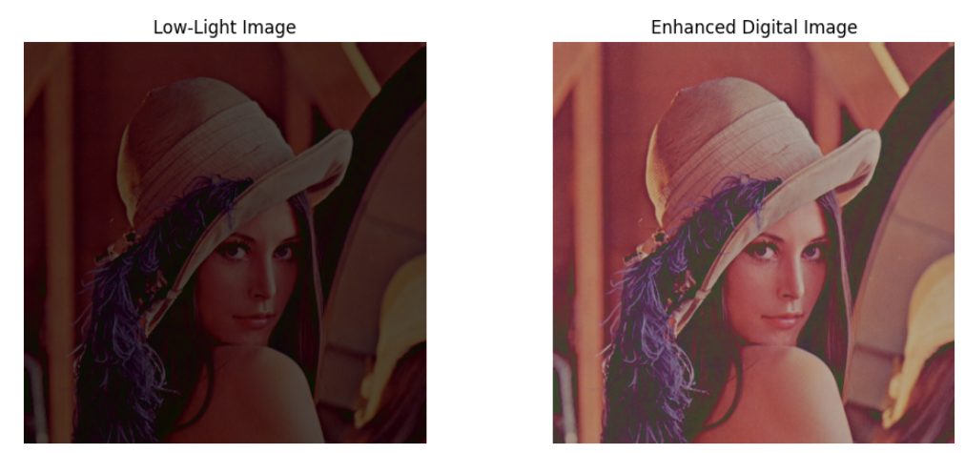

- In an application like facial recognition, explain how different levels of Computer Vision are involved from image acquisition to decision making.
Explanation: Facial recognition involves several levels of Computer Vision. First, the camera captures the face (image acquisition). The image is then preprocessed by converting it to grayscale and reducing noise. Next, the system detects the face and extracts important facial features. These features are compared with stored data to recognize the person. Finally, the system makes a decision, such as identifying the person or denying access if no match is found.
code:
# Import libraries
import cv2
import matplotlib.pyplot as plt
import urllib.request

# Download a sample face image
image_url = "https://raw.githubusercontent.com/opencv/opencv/master/samples/data/lena.jpg"
urllib.request.urlretrieve(image_url, "face.jpg")

# Download Haar Cascade classifier
cascade_url = "https://raw.githubusercontent.com/opencv/opencv/master/data/haarcascades/haarcascade_frontalface_default.xml"
urllib.request.urlretrieve(cascade_url, "haarcascade_frontalface_default.xml")

# Load the image
image = cv2.imread("face.jpg")

# Convert image to grayscale
gray = cv2.cvtColor(image, cv2.COLOR_BGR2GRAY)

# Load face detector
face_cascade = cv2.CascadeClassifier("haarcascade_frontalface_default.xml")

# Detect faces
faces = face_cascade.detectMultiScale(gray, scaleFactor=1.1, minNeighbors=5)

# Draw rectangles around detected faces
for (x, y, w, h) in faces:
cv2.rectangle(image, (x, y), (x+w, y+h), (0, 255, 0), 2)

# Display result
image_rgb = cv2.cvtColor(image, cv2.COLOR_BGR2RGB)

plt.figure(figsize=(6,6))
plt.imshow(image_rgb)
plt.title(f"Faces Detected: {len(faces)}")
plt.axis("off")
plt.show()

# Decision Making
if len(faces) > 0:
print("Decision: Face detected successfully.")
else:
print("Decision: No face detected.")

OUTPUT:
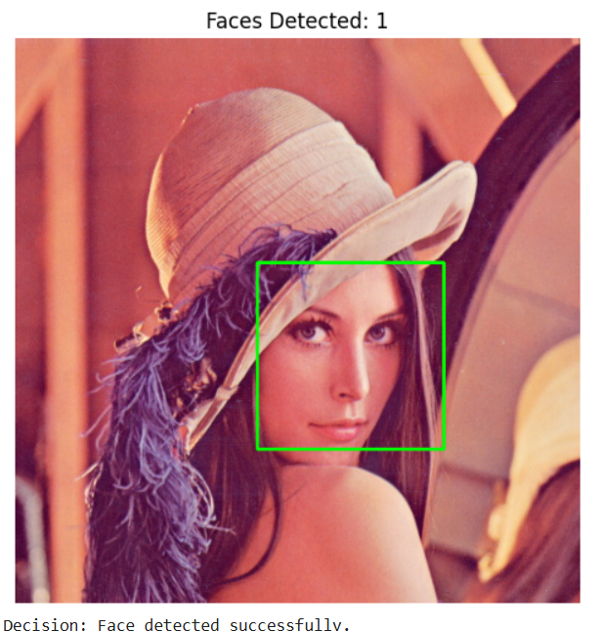

Code of Conduct:

I RAJA RAJESHWARI M (192421253) certify that this submission is my original work and that I have adhered to the guidelines specified for this assessment.
I understand that any violation of academic integrity rules will result in disciplinary action.
RAJA RAJESHWARI.M
Signature of the student:

